# 📘 01: Event Listeners

## 🔶 1. Event Listeners in JavaScript

### 🔸 What is an Event Listener?

A way to run JavaScript code when a user interacts with an element (like clicking, typing, etc.)

### 🔹 Syntax:

element.addEventListener("event", callbackFunction);

### 🔸 Subtopics:

#### ✅ 1.1 Inline onclick (Not Recommended)

<h1 onclick="console.log('Hey')">Click Me</h1>

* Runs JS directly from HTML.
* ⚠️ Not clean for large projects.

#### ✅ 1.2 addEventListener() (Recommended)

btn.addEventListener("click", function () {  
 alert("Button clicked");  
});

* Separates JS and HTML → cleaner code.
* Can add/remove multiple listeners.

#### ✅ 1.3 Named Function (for removal)

function sayHi() { alert("Hi"); }  
btn.addEventListener("click", sayHi);  
btn.removeEventListener("click", sayHi);

#### ✅ 1.4 Arrow Function

btn.addEventListener("click", () => console.log("Clicked!"));

#### 

#### ✅ 1.5 Common Events Table

| Event | When It Fires | Use Case |
| --- | --- | --- |
| click | On click | Buttons, toggles |
| mouseover | Mouse enters element | Tooltips, hover menus |
| mouseout | Mouse leaves element | Hide tooltips |
| keydown | Key is pressed | Shortcuts, key handling |
| keyup | Key is released | Search, typing |
| submit | Form is submitted | Form validation |
| input | Input is changing | Live typing, search |
| change | Input changed + blurred | Dropdowns, radios, checkboxes |

# 📘 02: Event Object

### 🔸 What is it?

* A special object passed to the event handler function.
* Holds all the info about the event.

### 🔹 Common Properties:

| Property | Meaning |
| --- | --- |
| event.target | Element that triggered the event |
| event.type | Type of event (e.g., "click") |
| event.preventDefault() | Stops default action (e.g., form submit) |

### 🧪 Example:

input.addEventListener("input", function (e) {  
 console.log(e.target.value); // logs input's current value  
});

# 📘 03: Event handling on form

## 🔶 Working with <form> Tag

### 🔸 Purpose:

* Used to collect and send user data to the server.

### 🔹 3.1 Key Attributes

| Attribute | Purpose |
| --- | --- |
| action | Target URL to send data to |
| method | GET (in URL) or POST (in body) |

### ✅ Important Behavior of <form> Tag:

The <form> tag is used to **collect and send data** from the user to a server.

When the form is submitted (e.g., by clicking a submit button), it sends the input data to the server using the specified method and action.

### 🧩 Key <form> Attributes:

1. **action** – URL where the form data will be sent. Example:

* <form action="/submit">

1. **method** – HTTP method used to send data:
   * GET: Adds data to URL (visible)
   * POST: Sends data in request body (hidden) Example:

* <form method="GET">

### 🌐 URL Structure with <input> Tags (in GET method):

Each <input> with a name attribute adds a **key-value pair** to the URL query string when submitted.

Example:

<form action="/search" method="GET">

  <input name="query" value="shoes" />

  <input name="color" value="red" />

  <button type="submit">Search</button>

</form>

When submitted, the URL becomes:

/search?query=shoes&color=red

If you change input names/values, the URL will change accordingly.

### 📌 Summary:

* <form> controls how/where data is sent.
* action = target URL
* method = how data is sent (GET → URL, POST → body)
* Each <input name="key" value="val"> becomes key=val in URL (if GET)

## 🔶 Form Events

### 🔹 submit Event (on <form>)

form.addEventListener("submit", function (e) {

  e.preventDefault(); // Stop page reload

  console.log("Form submitted");

});

✅ Use to:

* Validate input before sending
* Prevent default behavior
* Collect data using FormData

### 🔹 4.2 Input-related Events (on <input>)

| Event | Fires When... | Best For |
| --- | --- | --- |
| input | As user types | Live preview, search |
| change | After change + blur | Dropdown, checkbox, radios |
| focus | Input gets focus | Highlight or helper text |
| blur | Input loses focus | Validation on leave |
| keydown | Key is pressed | Detect shortcuts or keys |
| keyup | Key is released | Check Enter, real-time typing |

### 🧪 Focus and Blur Example:

<input onfocus="console.log('Focused')" onblur="console.log('Blurred')" />

## 

## PROJECT 01 – get live input and final input from user input

<form id="myForm">

  <input id="username" name="username" />

  <button type="submit">Submit</button>

</form>

<p id="output"></p>

const form = document.querySelector('#myForm');

const username = document.querySelector('#username');

const output = document.querySelector('#output');

// Live typing

username.addEventListener('input', (e) => {

  output.innerText = "Typing: " + e.target.value;

});

// Form submit

form.addEventListener('submit', (e) => {

  e.preventDefault();

  output.innerText = "Final Value: " + username.value;

});

**Concepts:**

1. Username.value we can use on input tag as we know input have username , and value property and that that comes from user input  
  
2. e.target.value it’s a event object of input to acces value .  
  
  
3. e.preventDefault stop page to refresh after get submitted but button inside form

## ✅ Final Tips:

* Use .value on input, not form.
* Use e.target to access the element that triggered the event.

## 🔶 6. FormData in JavaScript

### 🔸 What is FormData?

* A built-in JavaScript object to collect and work with **form inputs** easily.
* Used to **read**, **append**, or **send** form data (usually with AJAX or fetch).

### 🔹 6.1 How to Create FormData Object

const form = document.querySelector("form");  
const formData = new FormData(form);

✅ It grabs all input values **(that have a name attribute)** from the form.

### 🔹 6.2 Common Methods

| Method | Purpose |
| --- | --- |
| formData.get("name") | Get value of a field |
| formData.set("name", value) | Set/replace value |
| formData.append("name", value) | Add new value |
| formData.entries() | Loop over all key-value pairs |

### 

## PROJECT 02 – get Inpurt data using FormData

<form id="myForm">

  <input name="username" value="lamb" />

  <input name="email" value="lamb@example.com" />

  <button type="submit">Send</button>

</form>

Js---------------------------------------------------

const form = document.querySelector('#myForm');

form.addEventListener('submit', (e) => {

  e.preventDefault();

  const formData = new FormData(form);

  console.log(formData.get("username")); // lamb

  console.log(formData.get("email"));    // lamb@example.com

  for (let [key, value] of formData.entries()) {

    console.log(`${key}: ${value}`);

  }

});

### ✅ Use Cases:

* Send form data via fetch() (AJAX).
* Build form logic without manually reading every input.

**Concepts:**

1. const formData = new FormData(form);
2. **array destructuring**

It's a **destructuring for...of loop** that iterates over each entry (a [key, value] pair) returned by formData.entries().

* **formData.entries()** returns an iterator of [key, value] pairs from a FormData object.
* **for...of** is used to loop over iterable objects like arrays, strings, maps, or anything with a .next() iterator.
* **let [key, value]** is **array destructuring**, used to extract the key and value from each entry.

# 📘 04: Mouse Events

## 🔶 1. Mouse Events in JavaScript

### 🔸 What are Mouse Events?

Mouse events are fired when the user interacts with the mouse (clicking, moving, hovering, etc.) on the web page.

### 🔹 1.1 Common Mouse Events

| Event | When it Happens | Use Case Example |
| --- | --- | --- |
| click | On left mouse click | Buttons, links, toggles |
| dblclick | On double-click | Rename files, edit elements |
| mousedown | Mouse button pressed | Drag start |
| mouseup | Mouse button released | Drag end |
| mousemove | Mouse moves over element | Games, drawing, tracking |
| mouseover | Mouse enters an element | Show tooltip, highlight |
| mouseout | Mouse leaves an element | Hide tooltip |
| contextmenu | Right-click (context menu) | Custom right-click menus |

### 🔹 1.2 Basic Example: Click Event

<button id="btn">Click Me</button>

document.getElementById("btn").addEventListener("click", () => {  
 alert("Button was clicked!");  
});

### 

### 🔹 1.3 Example: mouseover and mouseout

 <div id="box"></div>

  <script>

    const box = document.getElementById("box");

    box.addEventListener("mouseover", () => {

      box.style.background = "yellow";

    });

    box.addEventListener("mouseout", () => {

      box.style.background = "white";

    });

  </script>

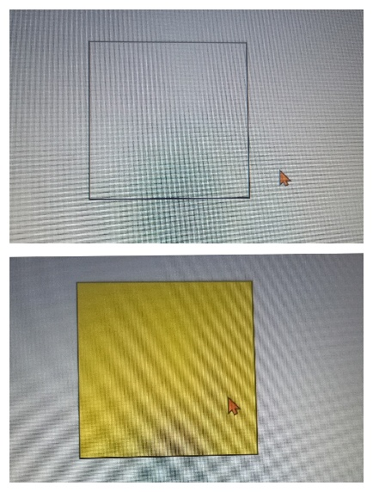

### 

### 🔹 1.4 Mouse Event Object Properties

| Property | Description |
| --- | --- |
| event.clientX | X position relative to viewport |
| event.clientY | Y position relative to viewport |
| event.target | Element that triggered the event |
| event.button | Which mouse button (0=left, 2=right) |

### 🧪 Bonus: Right Click Custom Menu

window.addEventListener("contextmenu", (e) => {  
 e.preventDefault(); // Prevent default right-click menu  
 alert("Custom Right Click!");  
});

PROJECT 03 – Create menu on right click of mouse   
  
pase1: when click on some field it show another component:  
Make intial component display hide and then turn on on click

## 

  <div class="container">

    right click me to see drop down

  </div>

  <button class="btn"> hidden container 👁️</button>

.container{

    height:450px;

    width: 400px;

    border: 2px solid black;

    display: flex;

    align-items: center;

    justify-content: center;

    display: none;

}

const container= document.querySelector('.container')

const btn= document.querySelector('.btn')

btn.addEventListener('click',(e)=>{

  e.preventDefault();

  container.style.display='block';

})

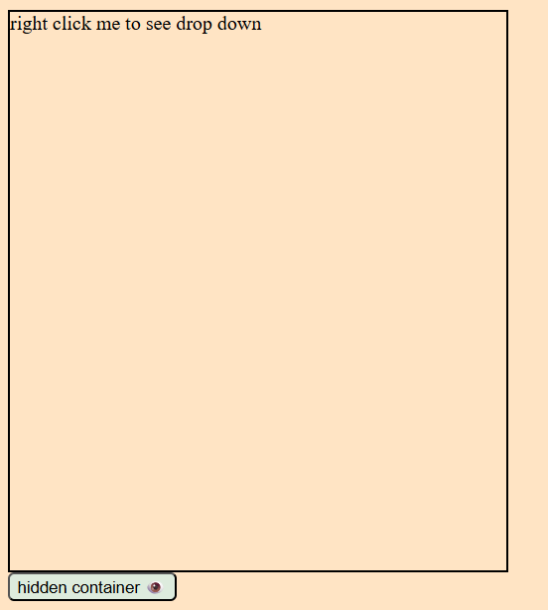

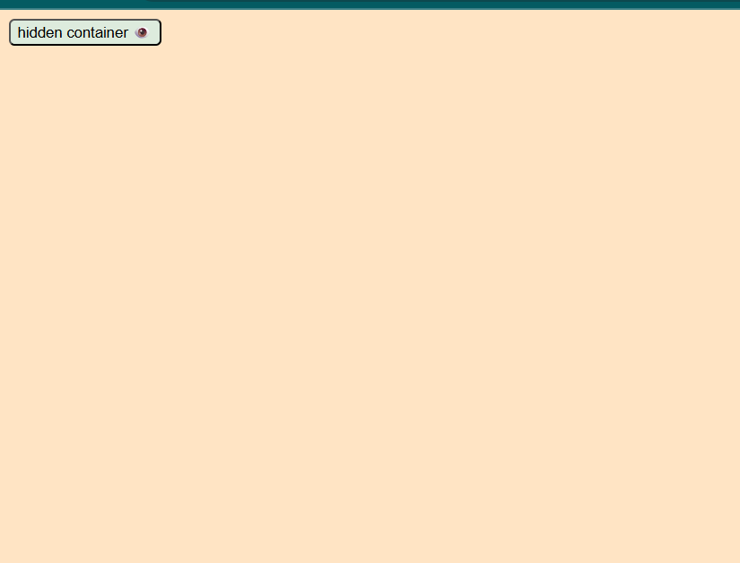

Project:  
Right click to open Menu:  
[Project Link](https://github.com/Lambodar2001/FrontEndDev2025/tree/07ef0c086e847bfe9f8a50e2929ca9112e5ae4b0/Ep4.%20DOM3-%20Event%20Listner/01_code_contextMenu_Mouse_event)

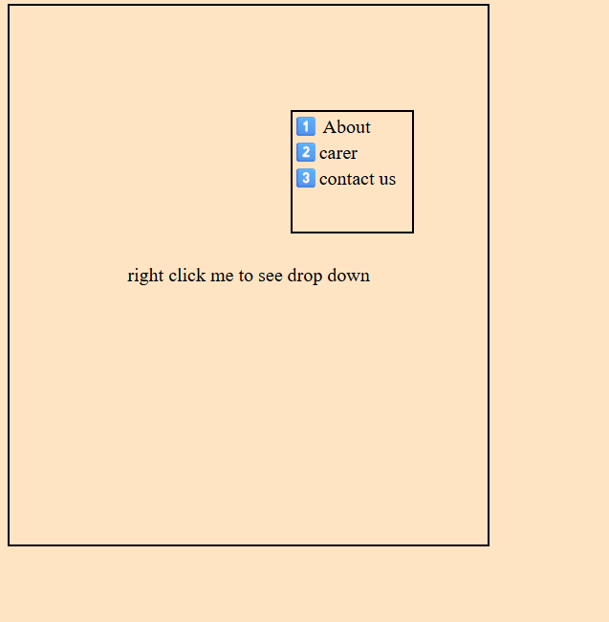

Concept:  
 1. Display property none/block on event fire

# 📘 05: Keyboard Events

## 🔶 2. Keyboard Events in JavaScript

### 🔸 What are Keyboard Events?

Keyboard events trigger when the user presses or releases keys on the keyboard.

### 🔹 2.1 Common Keyboard Events

| Event | When it Happens | Use Case Example |
| --- | --- | --- |
| keydown | Key is pressed down | Shortcuts, detect typing |
| keyup | Key is released | Form validation, live UI |
| keypress | (Legacy) Key is pressed | Not used in modern apps |

⚠️ Use keydown and keyup instead of keypress (deprecated in ES6+).

### 🔹 2.2 Basic Example: Detect Key Press

document.addEventListener("keydown", (e) => {

    e.preventDefault();

    console.log("Key pressed:", e.key);

});

Key pressed: s

2script.js:3 Key pressed: v

script.js:3 Key pressed: b

script.js:3 Key pressed: a

### 

### 🔹 2.3 Keyboard Event Object Properties

| Property | Description |
| --- | --- |
| e.key | The actual key (e.g., "a", "Enter") |
| e.code | Physical key location (e.g., "KeyA") |
| e.altKey | true if ALT was pressed |
| e.ctrlKey | true if CTRL was pressed |
| e.shiftKey | true if SHIFT was pressed |

### 

### 🧪 Example: Detect Enter Key on Input

<input type="text" id="username" />

document.getElementById("username").addEventListener("keydown", (e) => {  
 if (e.key === "Enter") {  
 alert("Enter was pressed");  
 }  
});

## ✅ Final Tips:

* Use mouseover / mouseout for hover effects.
* mousedown + mouseup = useful for drag actions.
* Prefer keydown/keyup over old keypress.
* Use e.key for readable key values like "a", "Enter".
* Combine ctrlKey, altKey, shiftKey for custom shortcuts.

Here are clean and simple notes on **Event Bubbling, Capturing, stopPropagation(), and { once: true }** — formatted just like your previous topics:

# 

# 06: Event Bubbling, Capturing & Control Methods

## 🔶 1. Event Bubbling vs Event Capturing

### 🔸 What are these?

When an event happens (like click), it **moves through the DOM** in phases:

* **Capturing Phase**: From <html> down to the clicked element.
* **Bubbling Phase**: From the clicked element **back up** to <html>.

### 🔹 1.1 Event Bubbling (Default)

* Event travels **from inner to outer** (child → parent).
* Handlers on parents will also trigger after child unless stopped.

🧪 Example:

<div id="outer">  
 <button id="inner">Click Me</button>  
</div>

document.getElementById("inner").addEventListener("click", () => {  
 console.log("Inner Clicked");  
});  
  
document.getElementById("outer").addEventListener("click", () => {  
 console.log("Outer Clicked");  
});

🔸 Output (on click):

Inner Clicked  
Outer Clicked

### 🔹 1.2 Event Capturing (Trick: Set { capture: true })

* Event goes **from outer to inner** (parent → child).
* You must manually enable it.

🧪 Example:

document.getElementById("outer").addEventListener("click", () => {  
 console.log("Outer (capturing)");  
}, { capture: true });  
  
document.getElementById("inner").addEventListener("click", () => {  
 console.log("Inner");  
});

🔸 Output:

Outer (capturing)  
Inner

## 🔶 2. stopPropagation()

### 🔸 What does it do?

It stops the event from **bubbling up or capturing down** beyond the current element.

🧪 Example:

document.getElementById("inner").addEventListener("click", (e) => {

  console.log("Inner Clicked");

  e.stopPropagation();

});

document.getElementById("outer").addEventListener("click", () => {

  console.log("Outer Clicked");

});

🔸 Output:

Inner Clicked

✔️ stopPropagation() = Stop other handlers above/below from firing.

## 

## 🔶 3. { once: true }

### 🔸 What does it do?

The event listener runs **only one time**, then automatically removes itself.

🧪 Example:

button.addEventListener("click", () => {  
 console.log("Clicked once only!");  
}, { once: true });

✔️ Useful for:

* One-time popups
* First-click actions
* Confirmations

## ✅ Summary Table

| Feature | Behavior |
| --- | --- |
| **Bubbling** | child → parent (default) |
| **Capturing** | parent → child ({ capture: true }) |
| stopPropagation() | Stops event from moving further |
| { once: true } | Runs listener just one time |

# 07: Event Delegation in JavaScript

### 🔸 What is Event Delegation?

Event Delegation is a technique where you attach a **single event listener** to a **parent element**, and handle events for **its child elements** through event bubbling.

### 🔸 How It Works:

1. Add event listener to the **common parent** (like a container).
2. In the handler, check event.target to see **which child** triggered the event.
3. Use if or matches() or classList.contains() to filter the target.

### 🔸 Example:

document.querySelector('.container').addEventListener('click', function(e) {

  if (e.target.classList.contains('card')) {

    e.target.remove(); // only runs if a .card was clicked

  }

});

### 🔸 Common Methods Used:

| Method | Use |
| --- | --- |
| e.target | The exact element clicked |
| .matches('selector') | Check if element matches a CSS selector |
| .closest('selector') | Find nearest ancestor (or self) that matches selector |
| .classList.contains('class') | Check if element has a specific class |

PROJECT 04 – Add and remove card with use of Event Delegation:  
  
Brute force

const container= document.querySelector('.container')

const card= document.querySelector('.card')

const btn= document.querySelector('.btn')

btn.addEventListener('click', (e)=>{

    const newCard = card.cloneNode();

    container.appendChild(newCard)

    newCard.addEventListener('click', ()=>{

        newCard.remove()

    })

})

Optimized :   
const container= document.querySelector('.container')

const card= document.querySelector('.card')

const btn= document.querySelector('.btn')

btn.addEventListener('click', (e)=>{

    const newCard = card.cloneNode();

    container.appendChild(newCard)

    newCard.addEventListener('click', ()=>{

        newCard.remove()

    })

})

container.addEventListener('click', (e)=>{

    if(e.target.classList.contains('card')){

        e.remove();

    }

})